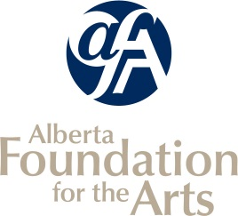
Community Support Organizations
Application Attachments

Planned Activities for the Upcoming Year

Organization Name:
Mandate:

Date From  (dd/mm/yy) | Date To  (dd/mm/yy) | Name of Self-Produced Performance | Venue | City/Town
Please complete this form and upload it as an attachment to your grant application through GATE.

